Documented Debugging and Flowcharts
Jonathan Guadron Portillo
November 1, 2.2
I reused my Bottle Countdown program from Assignment 1.3. The program checks the starting number, calls the countdown function, and displays a reminder to buy more beer when the countdown ends.
Main Program
Start main

Countdown Function
The function counts down to zero, chooses the correct bottle wording, and subtracts one bottle after each verse. It then returns to the main program.
Display reminder Remember to buy more beer!

returns
yes
no
Display input error message
Call countdown bottles with starting count
End main
Integer conversion succeeds and count is at least 1?
Ask for starting bottles
1 Breakpoint before the function call
placed a breakpoint on line 61, before calling countdown_bottles(starting_botlles). I started debugging and entered 3. The program paused at the breakpoint, and the debugger showed starting_bottles = 3 and valid_input = True. This confirmed that the input passed validation before being sent to the function.
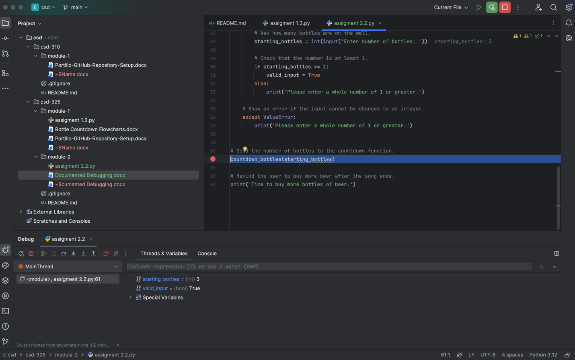
NO
Display take one down with plural bottle remaining
Bottles_after_drinking == 1?
Bottles_remianing = bottles_remaining -1
Display a blank line
Display take one down with 1 bottle remaining
Display 1 bottle verse then display 0 bottles
bottles_after_driking = bottles_remaining -1
Display current verse using plural bottles
NO
yes
bottles remaining == 1?
Return to main program
NO
bottles remaining >= 1?
Bottles remaining = starting bottles
Start countdown function
2. Step into the function
Observation: I used Step Into to enter the countdown_bottles function. The debugger paused on line 13, before assigning starting_bottles to bottles_remaining. The variables panel showed starting_bottles = 3 confirming that the function received the number entered in the main program

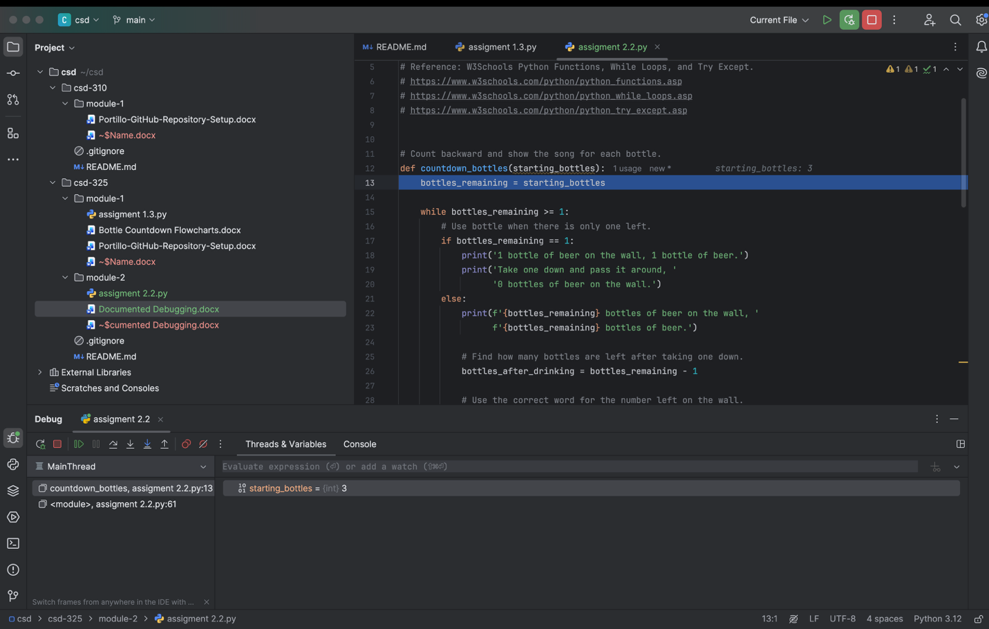
3. Step through a countdown iteration
Observation : I used Step Over to move through the first countdown iteration. After execution the subtraction on line 38, bottles_remaining changed from 3 to 2. The debugger returned to the while condition on line 15, ready to check whether another iteration should run. This confirmed that the program subtracts one bottle after each verse.


